**Video Rendering Demo Using Creatomate in Zapier.com**

This section shows how to leverage Creatomate to render your own videos within the automated process of Zapier. In general, there are three steps to create a demo video from the saved creatomate template.

图形用户界面

First, we need to add a trigger event, which in this case is the value push from Zapier Chrome extension. For instance, we would like to take two parameters ‘Text’ and ‘Video URL’, so we create these two parameters in this module.

Then create the Creatomate module, connect to your registered account and choose the template to use. Fill in the parameters retrieved from the Zapier Chrome extension push. In particular, Video URL should be in mp4 format. Text will be used to replace the default text in the template. Finally, send an email with the URL of the created video from Creatomate.

Now, publish the Zap and let us have a look at the demo result:

The email is successfully sent with the Creatomate rendered video URL [attached](https://cdn.creatomate.com/renders/f8aeb948-32a4-4cbf-b8b8-57ea847e5c4a):

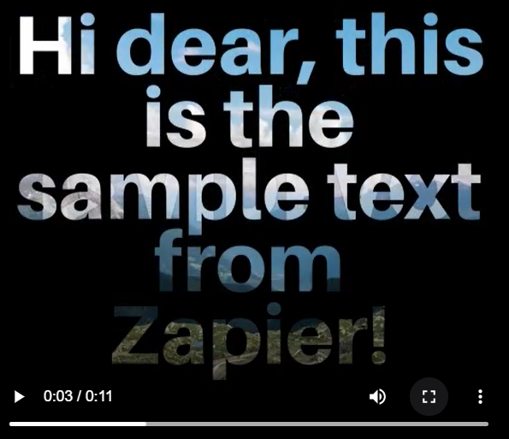

**Video Rendering Demo using Creatomate in Make.com**

In another example, let us try to do Creatomate video rendering using Make.com. The processes are relatively similar to the previous one, but we can try to publish the created video to our social media, such as our Instagram reel.

图标

In the first step, we need to set up the parameters and values that we would like to pass to Creatomate template for video rendering. Then fill up the parameter values into Creatomate template, seen in the picture below:

Eventually, pass the URL which is the URL of the created custom video from Creatomate to Instagram module as well as set up the other parameters, such as the Page, Caption, Cover Image, etc., to publish the video as an Instagram reel post. Run the workflow, then we can check out the created video on our Instagram channel.

